Can AI truly grasp the essence of music?

When a user enters a prompt like "Bossa Nova style, 6/8 time, mezzo-soprano, acoustic guitar with analog synth pad", what exactly happens inside an AI music generation model? Does it work like a trained composer who understands the acoustic relationships between these music theory terms and makes informed creative decisions based on that understanding?

Given the current state of mainstream AI music generation — whether based on diffusion models or Transformer architecture — the AI does not actually "understand" music theory. Here's how it works: first, through deep learning, the model learns the statistical distribution of acoustic features from massive amounts of audio training data. Then, based on the user's prompt, it performs conditional acoustic fitting — statistically finding the content structure that best matches the prompt. Finally, the model outputs what it believes to be the most suitable musical result. In other words, the AI is not inferring chord progressions or calculating interval relationships; it's determining which acoustic pattern in its training data most likely corresponds to the description, and then generating the closest possible match.

But that doesn't mean all tools perform at the same level. The quality of the training data, the granularity of prompt parsing, and whether the platform provides sufficient parameter controls together determine how faithfully the output reproduces elements of music theory.

This difference is exactly what this review is about.
To scientifically assess how faithfully AI can reproduce music theory elements, this article tests three AI music generation platforms with different positioning: MakeBestMusic, ilovesong, and AIVA. We designed targeted tests around the four fundamental building blocks of music — style, rhythm, pitch, and timbre — to evaluate how well each platform parses and executes music theory information from prompts.

Evaluation Dimensions Explained

Music consists of four basic elements: style defines the grammatical system of musical language, rhythm builds the temporal framework, pitch defines the vertical space of melody and harmony, and timbre gives sound its unique identity. How well an AI tool understands these four elements directly reflects its ability to turn text descriptions into competent musical output. Based on this, we set up the following four corresponding metrics:

- Style Understanding & Execution
: Tests how accurately the AI reproduces the musical language of a given style description. The test covers not only mainstream genres like Pop and Rock but also niche styles like Bossa Nova and Drill. It examines whether the tool can distinguish subtle differences between similar genres (e.g., Trip-Hop vs. Downtempo) instead of lumping all non-mainstream styles into "electronic music."

- Time Signature & Complex Meter
Tests the AI's response accuracy to non-standard time signatures like 3/4, 6/8, 5/4, and specific BPM instructions. Most AIs default to 4/4. Whether a tool can switch to a waltz's 3/4 or an experimental 7/8 while maintaining rhythmic stability and structural integrity is a key differentiator.

- Vocal Range Specification
tests the AI's ability to follow specific voice part instructions, such as bass, mezzo-soprano, or child voice. Evaluation focuses not only on whether the correct voice part is generated, but also on the naturalness of transitions between high and low registers and the absence of distortion at range extremes.

- Timbre Specification
Evaluates the AI's ability to parse instrument timbre and acoustic detail descriptions. For example, when the prompt specifies "acoustic guitar," does the AI mistakenly output an electric guitar sound? When "analog synth pad" is requested, can it distinguish the warmth difference from a digital synth? This reflects the model's granularity in identifying acoustic characteristics of instruments.

- Each dimension is scored out of 5, for a total of 20 points, forming a structured evaluation framework for the tool's ability to execute music theory elements.

Regardless of whether the user inputs style tags, rhythm parameters, or voice part names, the AI's core task is the same: map these music theory terms from the text into the corresponding acoustic feature space from its training data, and generate the optimal audio output under multiple constraints. The accuracy of this mapping depends on two levels: the depth of model training determines how many acoustic patterns it "knows," and the parameter control interface provided by the platform determines how much the user can refine the constraints. Understanding this underlying logic makes the following breakdown of the three tools clearer.

Quick Overview: Total Scores for Music Theory Understanding

The results show: thanks to its deeply trained foundation model and well-designed feature framework, MakeBestMusic delivers the most complete and balanced understanding and execution across all four music theory dimensions — the only platform in this test to score above 4.5 in every dimension. AIVA, with its strong classical and orchestral DNA, performs reliably in style and timbre, but its purely instrumental focus makes the vocal dimension a clear weakness. ilovesong, as a lightweight text-to-song tool, is usable for basic scenarios but has structural limitations in fine-grained control over music theory elements.

评测维度 | MakeBestMusic | ilovesong | AIVA
风格理解与执行（满分5） | 4.5 | 3.0 | 4.0
拍号与复杂节拍（满分5） | 4.5 | 2.5 | 3.5
人声指定音域（满分5） | 5.0 | 3.5 | 2.0
指定音色（满分5） | 4.5 | 3.0 | 4.0
总分（满分20） | 18.5 | 12.0 | 13.5

Next, we'll walk you through the specific test content and how each tool performed.

MakeBestMusic: The All-Round Professional Composition Platform | Total Score 18.5/20

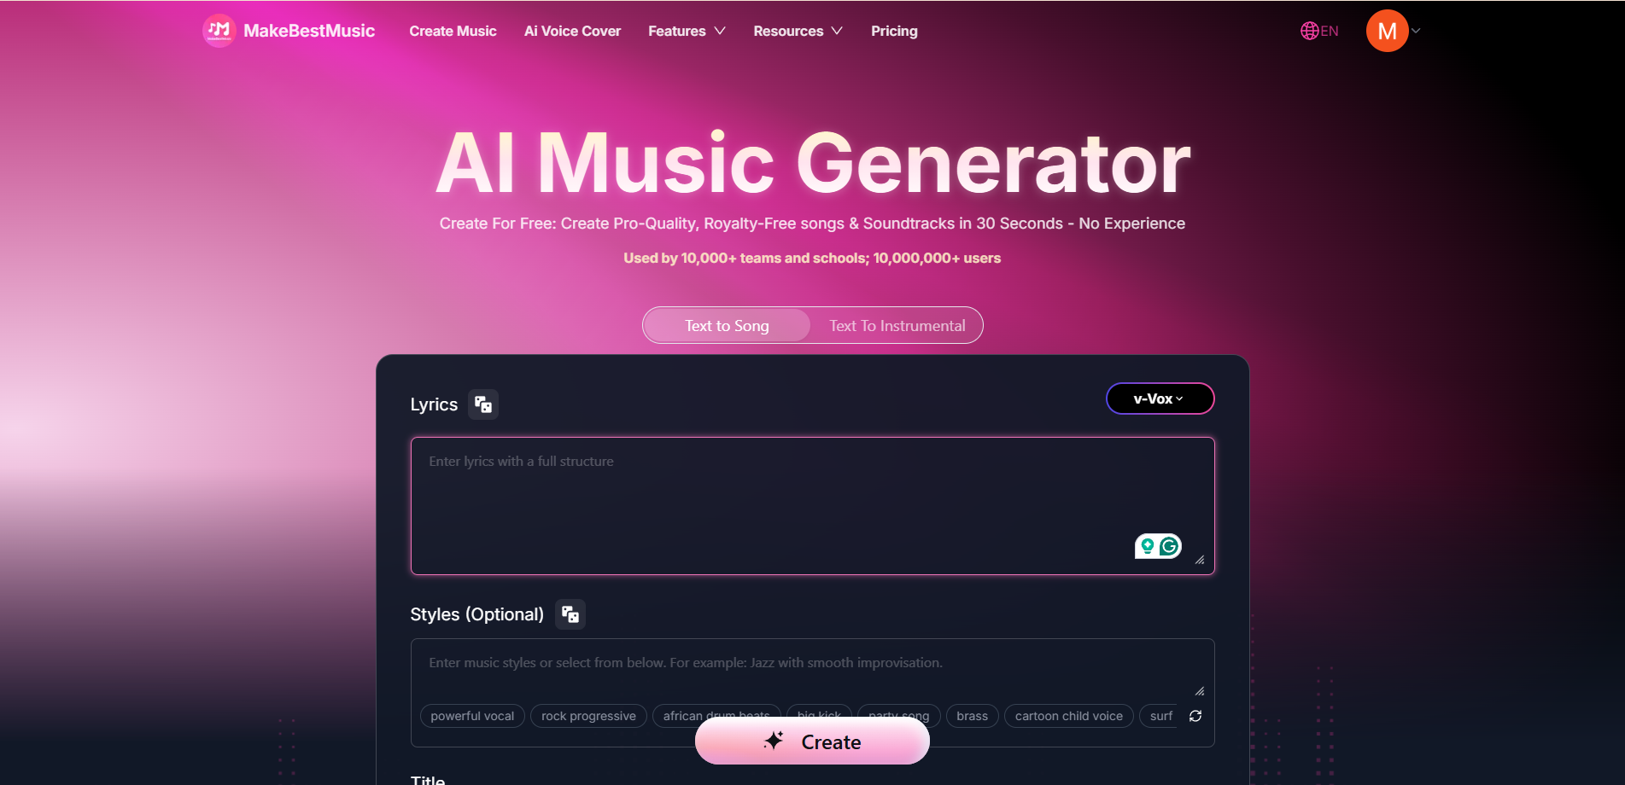

Positioning: Currently, the most complete platform for music theory element understanding and execution, offering both deep parameter control and a low-barrier creative entry point.

MakeBestMusic's ability to score above 4.5 across all four dimensions comes not only from the quality of its underlying model, but also from its multi-level, fine-grained prompting framework that goes beyond simple natural language prompts. From Simple Mode (one-click generation) to Custom Mode (full parameter control) to Meta Tags (bar-level precise instructions), users can choose their control granularity based on their own music theory knowledge.

Style Understanding & Execution: 4.5/5

MakeBestMusic's Custom Mode provides a highly granular Style Prompt input channel. Users can specify genre, key, BPM, instrumentation, and even chord progressions in the style description. The platform's built-in genre support list covers dozens of sub-categories from Avant-garde and Electroacoustic to Bossa Nova and Dancehall.

This level of detail means that when a user needs a piece that is "Contemporary R&B with Neo Soul chord colors, B-flat major, 72 BPM," the Style Prompt can pass each of these elements as independent constraints to the model, rather than compressing them into a vague style tag.

A key differentiator is the Meta Tags system. By embedding structural tags like [Verse 1: piano solo, female vocal] and [Chorus: full band, male vocal] into the lyrics, users can achieve bar-level style switching — verse is piano solo with female voice, chorus cuts to full rock instrumentation with male voice. This precise control over multi-style fusion within a single piece is not found in the other two tools tested. The Style Influence slider in Advanced Options provides a quantitative way to control how strictly the generation follows the style description, largely avoiding the common frustration of "detailed prompts but the AI does whatever it wants."

Time Signature & Complex Meter: 4.5/5

Style Prompt supports direct input of BPM values and time signatures (e.g., "5/4 time, 140 BPM"). In testing, it performed excellently with 3/4 and 6/8, and even for experimental meters like 5/4 and 7/8, it maintained basic rhythmic integrity without noticeable tempo drift at section transitions.

The Meta Tags feature, including bar-count specifications like [Intro 16 bars], allows rhythm control down to the exact length of a section, preventing the AI from arbitrarily adding or removing bars at transitions. Combined with the Weirdness parameter (which controls harmonic complexity), MakeBestMusic demonstrates stable rhythm maintenance even in Progressive Rock or experimental electronic styles that require frequent meter changes.

Vocal Range Specification: 5.0/5

This is the dimension where MakeBestMusic achieves a perfect score, and it is its most significant advantage over competitors. The platform offers a complete Vocal Meta Tags system, supporting precise specification of voice parts such as male bass, female mezzo, child voice, teen voice, and even complex voice combinations like mixed choir, Barbershop Quartets, and A cappella.

In testing, after specifying "female mezzo solo with layered robotic harmony," the generated result accurately delivered a mezzo-soprano lead melody with a robotic-texture harmony layer. The vocal separation between parts was clear, with no overlapping ranges or distortion. This complete support chain — from single voice parts to multi-voice combinations — together with the Persona feature (which allows users to upload their own audio to extract voice characteristics and apply them to future creations, a core implementation of the AI Singing function) forms a highly integrated vocal creation loop.

Timbre Specification: 4.5/5

The Style Prompt supports high-precision timbre terminology in instrumentation descriptions, such as "acoustic guitar, analog synth pad, thundering timpani, soaring string section." In testing, specifying "acoustic guitar" vs. "electric guitar" produced clearly distinguishable timbral results. The differences in warmth and spectral distribution between analog synth pads and digital synths were also largely reproduced.

The Exclude Styles feature allows users to negatively exclude unwanted instruments or style elements, adding a "subtractive" dimension to timbre control. Specifying "exclude distorted electric guitar" — even within a Rock style framework — resulted in outputs that maintained clean guitar timbre.

Who It's For

- Professional music producers and arrangers who need precise control over music theory elements like style, meter, voice, and timbre — Meta Tags and Advanced Options provide the necessary depth.

- Independent musicians and singer-songwriters who want an all-in-one workflow from lyric generation (an AI lyric writer is built into Custom Mode) to arrangement, vocals, and mastering.

- Content creators and film/TV composers who need to quickly produce multi-style, specified-duration music — Extend and Reference features efficiently handle batch customization.

When the same prompt is used across different platforms, the results are often dramatically different — especially in high-complexity style scenarios. As we move from a control-oriented platform to lightweight creative tools, the impact of design trade-offs on music theory execution becomes even more obvious.

ilovesong: Lightweight Song Generator | Total Score 12.0/20

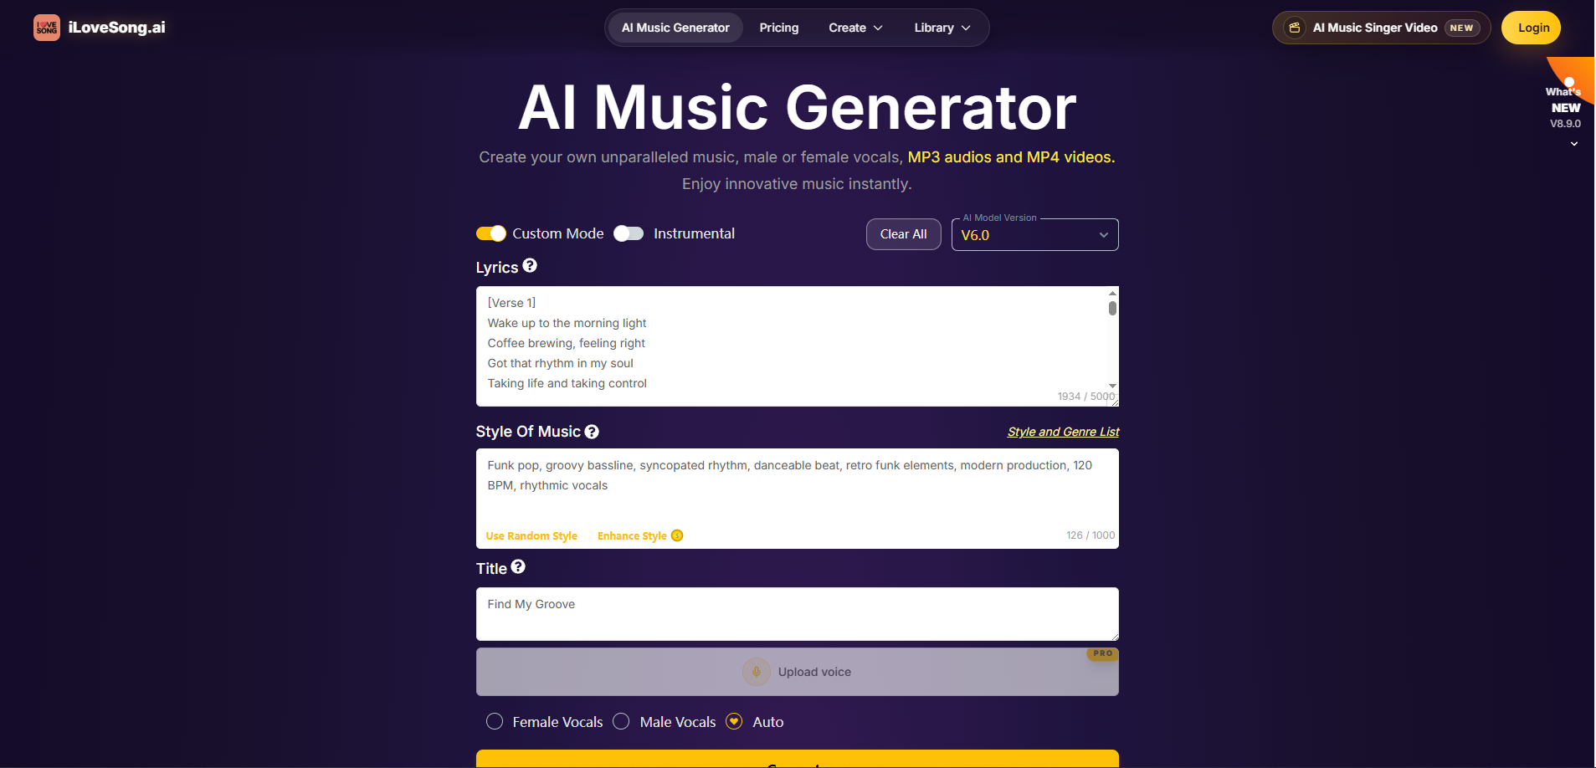

Positioning: A fast song generation tool for absolute beginners. Its strength is an extremely low entry barrier, but it has structural limitations in fine music theory control.

ilovesong's core mission is to lower the creative barrier, allowing users to quickly get a complete song from a short text description. This design philosophy makes it smooth for "just casually make a song" scenarios — enter an emotional description and a rough style preference, and in seconds, you get a full song with lyrics and vocals. For creators who need to produce background music for social media quickly, this efficiency-driven concept is clearly appealing.

Style Understanding & Execution: 3.0/5

ilovesong provides preset style tags covering Pop, Rock, Hip Hop, EDM, and other mainstream genres. Within these common styles, the results are reasonably recognizable. However, when the test enters niche territory — e.g., distinguishing Cool Jazz from Bebop, or requesting a style switch within the same song — the platform's style parsing precision drops significantly, with outputs tending to "regress" to the nearest mainstream type. This is largely due to its simplified prompt input design, which lacks separate channels for instrumentation, key, or chord progression descriptions. All style information is compressed into a single text box, making it difficult for the model to prioritize different elements.

Time Signature & Complex Meter: 2.5/5

The platform does not provide explicit time signature or BPM input controls. When writing "3/4 time" or "waltz rhythm" in the text description, the output occasionally captures a triple-meter feel, but reliability is low; some sections unconsciously slip back into 4/4. Complex meters like 5/4 and 7/8 never received effective responses in multiple tests — the output always remained in 4/4. This suggests that non-standard time signatures are underrepresented in the training data, and the interface lacks a forced mechanism to pass meter information, giving users very limited control in this dimension.

Vocal Range Specification: 3.5/5

ilovesong supports basic voice part gender selection, and the vocal quality is usable — especially stable in the mid-range for pop styles. But fine-grained voice part specifications (e.g., distinguishing soprano from mezzo, specifying bass range) lack input interfaces. When writing "male bass voice" in the text description, the resulting vocal range did not shift significantly lower compared to an ordinary male voice. Moreover, voice combinations (e.g., duets, choirs, lead with harmony layers) are not supported.

Timbre Specification: 3.0/5

Instrumentation control mainly relies on style tag associations: choosing "Acoustic" style tends to produce acoustic guitar and piano sounds; choosing "EDM" yields synths and electronic drums. But when a user wants to substitute timbres within the same style framework — e.g., "Pop style but replace guitar with ukulele" — the platform lacks the descriptive precision to make such targeted adjustments. Timbre choice is largely determined by the style preset, not by active user control.

Who It's For

- Social media content creators who need quick background music or short video scores with low music theory demands.

- Music enthusiasts and beginners who want to experience AI music creation with zero learning curve.

- Lightweight demo makers who need to quickly validate a rough song idea before moving to professional tools for refinement.

Returning to a professional-grade creative tool from a lightweight one, AIVA represents a distinctly different design path — it chooses to go deep in a vertical niche (instrumental composition) rather than covering the entire song creation workflow.

AIVA: Classical & Film Scoring Expert | Total Score 13.5/20



Positioning: An AI platform focused on instrumental composition and orchestration, with deep style execution in classical, film scoring, and symphonic music. However, its purely instrumental positioning creates inherent limitations in vocal-related dimensions.

AIVA originally gained recognition for classical music composition, with its model trained on high-quality data in symphonic, chamber, and film music. In a typical use case — a film producer needing "a string quartet in Baroque counterpoint style, minor key, medium-slow tempo" — AIVA delivers remarkably professional results in stylistic accuracy and voice-leading. This vertical depth is its core competitive strength.

Style Understanding & Execution: 4.0/5

AIVA's execution precision in classical and film scoring styles approaches that of MakeBestMusic. The platform offers various preset style templates covering Baroque, Classical, Romantic, Modern Orchestral, and more. Users can also guide generation via mood tags and reference tracks. When given a professional description like "20th-century Impressionist orchestral style, mostly whole-tone scale," the output matches the expected harmonic color and instrumental texture.

However, when style requirements stray from its core domain — e.g., specifying Trap beats or K-Pop dance arrangements — the accuracy drops significantly, reflecting that the training data covers pop and electronic music less densely than classical and film scoring. Additionally, AIVA does not provide a bar-level style switching system; style variations within a piece rely on the model's automatic interpretation of the overall description.

Time Signature & Complex Meter: 3.5/5

AIVA demonstrates solid basic meter control. The platform supports direct setting of time signature and tempo via parameter controls, with high reliability for 3/4 and 6/8 — directly related to its classical training data, which contains many non-4/4 pieces like waltzes and barcarolles. In testing, specifying a 6/8 barcarolle style produced accurate compound meter feel and accent patterns.

5/4 performance is acceptable but occasionally has bar-level rhythmic fluctuations. Asymmetric meters like 7/8 are less stable in repeated tests compared to MakeBestMusic. Also, AIVA does not support specifying exact bar counts in the creation interface, offering less precision than Meta Tags' bar-level control.

Vocal Range Specification: 2.0/5

This is AIVA's lowest-scoring dimension, fundamentally due to the platform's own positioning of its output.

AIVA's core output is purely instrumental; it does not provide lyric input, vocal generation, or voice part specification features. For songwriting scenarios that require vocals, AIVA must be used with external vocal synthesis tools or live recordings — it cannot complete an integrated instrumental-to-vocal workflow. The score is 2.0 instead of 0 because certain choir-like presets within some orchestral templates can produce a choral-texture effect that mimics vocal qualities. But strictly speaking, this is an instrumental treatment of vocals in a symphonic context, not true vocal generation.

Timbre Specification: 4.0/5

In terms of orchestral instrument timbre, precision, and layering, AIVA performs very well. String sections (violin, viola, cello, double bass) have high separation, woodwinds and brass show accurate overtone characteristics, and percussion dynamic response meets symphonic writing standards. When specifying "French horn melody, string tremolo accompaniment, timpani roll," the timbral clarity and spatial positioning of each section reach professional levels.

But for electronic sounds and modern pop instrumentation, AIVA also has gaps. When specifying "analog synth pad" or "808 bass," the output's timbral specificity is not as clear as with classical instruments, sometimes resulting in a generic synthesizer texture. Moreover, AIVA does not offer a subtractive exclusion feature like Exclude Styles, limiting user control over timbre in the negative sense.

Who It's For

- Film and game composers who need rapid, high-quality orchestral scoring drafts — AIVA's efficiency and quality in this vertical are top-notch.

- Classical music learners and composition students who want to explore harmonic arranging and orchestration possibilities via AI; MIDI export facilitates further analysis in notation software.

- Advertising and corporate video production teams who need vocal-free background music with a preference for traditional instrumental styles like orchestral or piano.

Comparison Summary

The differences in music theory understanding among the three tools essentially reflect their different design trade-offs.

- Style dimension: MakeBestMusic, with its multi-layer Style Prompt system and Meta Tags, achieves full coverage from macro style to micro sections. AIVA approaches the same precision within its classical/film scoring comfort zone but has limited cross-style capability. ilovesong's style execution relies on preset tag associations without fine-grained user control channels.

- Rhythm dimension: MakeBestMusic's direct BPM/signature input, Meta Tags bar-count specification, and Weirdness parameter form a three-layer rhythm control mechanism. AIVA performs reliably on classical common meters like 3/4 and 6/8 but lacks bar-level duration precision. ilovesong has the lowest response rate for non-standard meters.

- Vocal dimension: The gap is largest here. MakeBestMusic is the only tool among the three that offers complete voice part type tags, voice combination commands, and personalized voice cloning (Persona). ilovesong supports basic voice gender selection but lacks fine range control. AIVA, due to its instrumental focus, essentially does not handle vocal generation.

- Timbre dimension: MakeBestMusic's dual additive (detailed instrumentation description) and subtractive (Exclude Styles) control logic offers the most flexible timbre definition space. AIVA excels in orchestral timbre depth but falls short on electronic sounds. ilovesong's timbre choices are largely indirectly determined by style presets.

FAQ

1. Can I quickly test a harmony and orchestration idea using AI?

Yes, MakeBestMusic's built-in Midi Studio feature does this. In Midi Studio, users can directly edit harmonic structures and orchestration choices, and the AI generates corresponding audio in real time. This WYSIWYG approach to harmony/orchestration testing eliminates the tedious workflow of manually writing MIDI in a DAW, loading sound libraries, and adjusting tracks one by one. It's especially useful for early-stage validation of chord progressions and instrumental combinations.

2. How can I quickly get detailed pitch and rhythm information from AI-generated music?

Use MakeBestMusic's Split Music function. Select the Advanced stem-splitting mode, and the platform will separate the generated output into up to 12 independent tracks, including MIDI tracks. The exported MIDI file contains the pitch sequences, rhythmic timing, and velocity information for each part. This can be imported directly into any DAW or notation software for analysis, editing, or re-creation. For users who need to know exact interval relationships or rhythmic details of an AI-generated melody, this is far more efficient than repeatedly listening to the audio.

3. Can AI output high-fidelity DAW-ready assets directly?

Yes. MakeBestMusic supports lossless WAV downloads, preserving the full dynamic range and spectral detail of the audio, meeting the quality requirements of professional mixing environments. The platform also provides an Audio Converter function for converting between different audio formats, so users can choose the most appropriate format for their workflow without third-party tools.

4. What if the generated result sounds a bit thin?

MakeBestMusic's Music Mastering feature effectively addresses this. It applies automated mastering processing — including dynamic range optimization, spectral balancing, and loudness normalization — to make the output sound fuller and more layered. For users without professional mastering experience, this one-click feature significantly closes the perceptual loudness and density gap between AI-generated music and commercial-release audio.

5. Besides prompts, is there any other way to improve alignment with my creative intent?

MakeBestMusic's Reference function offers another control path beyond prompts. Users can upload a reference audio clip; the system will use its style, rhythmic structure, and melodic characteristics as additional constraints for re-creation. Reference supports five types of targeted adjustments: style transfer, instrument replacement, vocal change, lyric adaptation, and extending a melody snippet into a full piece. Compared to text-only prompts, reference audio provides more intuitive and harder-to-describe acoustic information. Combining both greatly improves alignment between output and creative intent. The Audio Influence parameter in Advanced Options allows quantitative adjustment of how much the output relies on the reference audio's features, enabling precise "similar but different" control.

Conclusion: Choosing the Right Tool Matters More Than the Debate

So, can AI really read a musical score? After hands-on testing of three tools, a more practical conclusion emerges: instead of debating whether AI "understands" music theory, focus on how well it can execute it to meet your needs. The precision with which the four elements — style, rhythm, pitch, and timbre — are reproduced ultimately depends on the quality of model training and the platform's control framework, not on whether the AI has genuine musical cognition.

But no matter how well-designed a tool is or how efficient its workflow is, the core of operation and decision-making is always the creator. AI is just an assistant to realize your ideas. Regardless of your music theory background, finding a tool that faithfully translates your creative intent into sound is what truly deserves your time in the AI music era.

Now, go try out the tools based on our review — experiment with preset models, make manual tweaks in post-production. Through your own practice, you'll gradually learn the scope and boundaries of each tool. After all, the only truly valid judgment comes from your own experience

